

**Disclaimer: The content is curated from online/offline resources and used for educational purpose only**



**LAB MANUAL**

**Unit III – Power BI for Data Analysis**

**Unit III – Understanding rainfall data and prediction using power BI**

**Lab - 1**

**Objective:**

The purpose of this lab session is to teach students how to import, transform, visualize, and analyze rainfall data in Power BI. By the end of the session, students will also learn how to predict future rainfall trends using built-in Power BI forecasting capabilities.

* Learn how to import datasets into Power BI from various sources (e.g., Excel, CSV).
* Understand how to clean and transform data in Power Query.
* Learn to create calculated columns
* Master creating various visualizations (line charts, bar charts, maps) to visualize rainfall trends and patterns.
* Learn how to create comparative visuals (e.g., seasonal rainfall comparison).
* Learn basic concepts of trend analysis using time-series data.
* Learn how to create dashboards to summarize key insights.

**Prerequisites:**

* Basic knowledge of Power BI (interface and common visualizations).
* Familiarity with Excel/CSV file formats.
* Basic understanding of data analysis concepts like aggregation, grouping, and filtering.
* Basic knowledge of time-series data and its application in forecasting.

**Software Required:**

* Power BI Desktop (latest version)

**Step-by-Step Procedure:**

**Step 1: Data Import**

1. Open Power BI Desktop.
2. Import Dataset:
   * Click on Home in the ribbon and then select Get Data.
   * Choose the appropriate data source (Excel or CSV).
   * Browse to the dataset file and click Load.

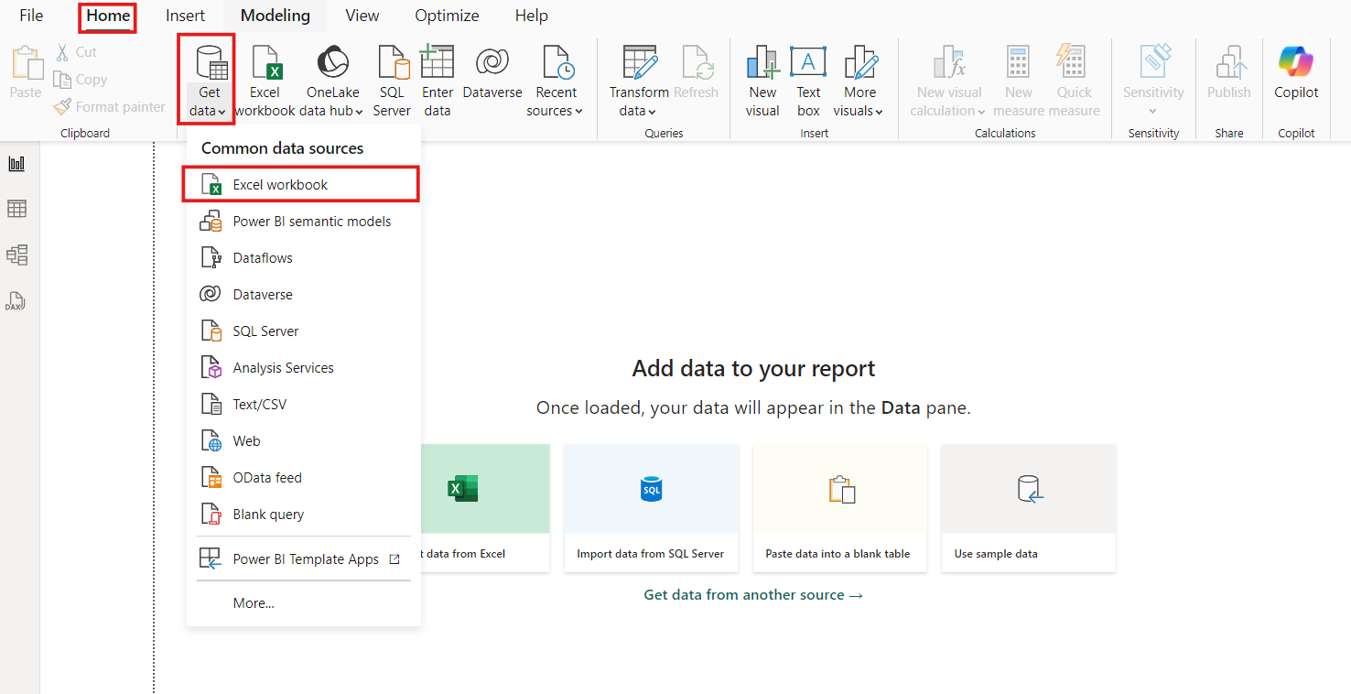

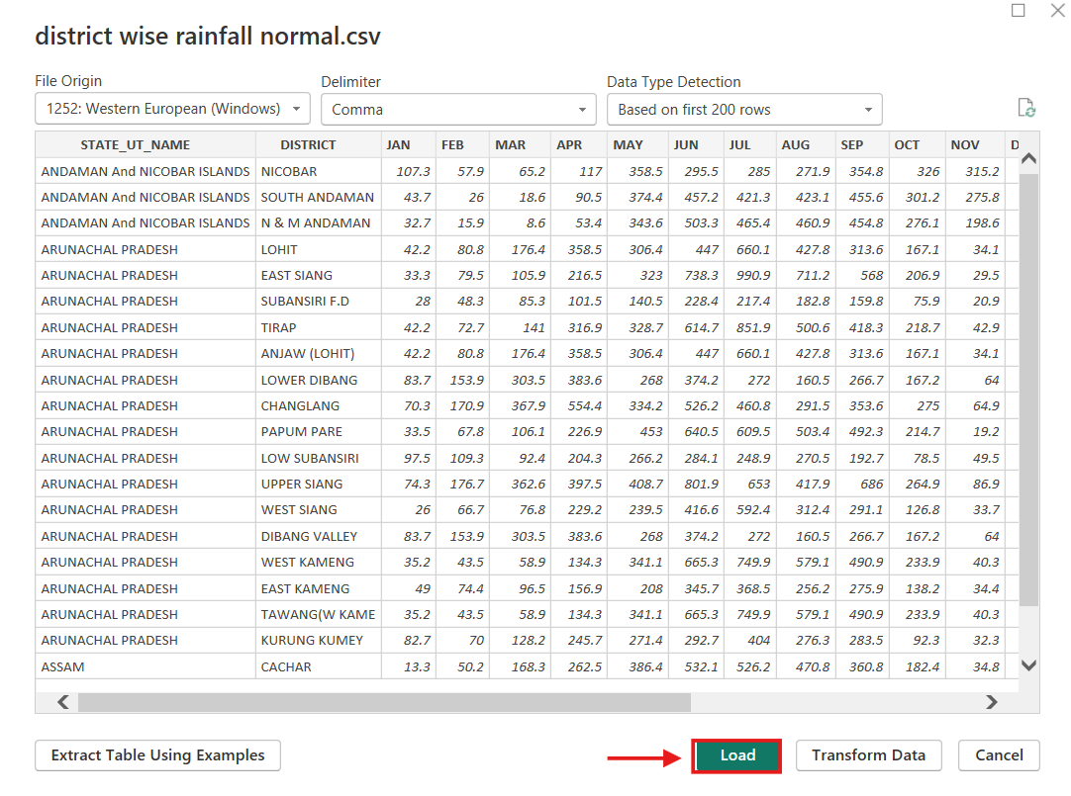

1. Verify Data:
   * Go to the Data view in Power BI.
   * Check the dataset for correctness. Ensure that each column has the correct data type (e.g., numeric for rainfall data, text for STATE_UT_NAME and DISTRICT).



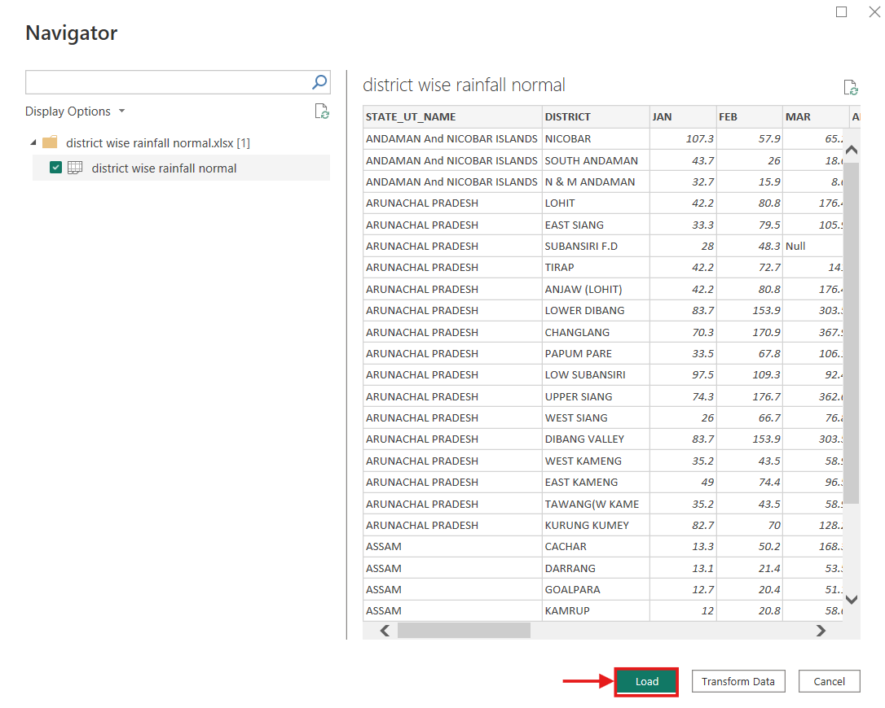

**Step 2: Data Cleaning and Transformation in Power Query**

1. Open Power Query Editor:
   * Go to Transform Data to open Power Query Editor.

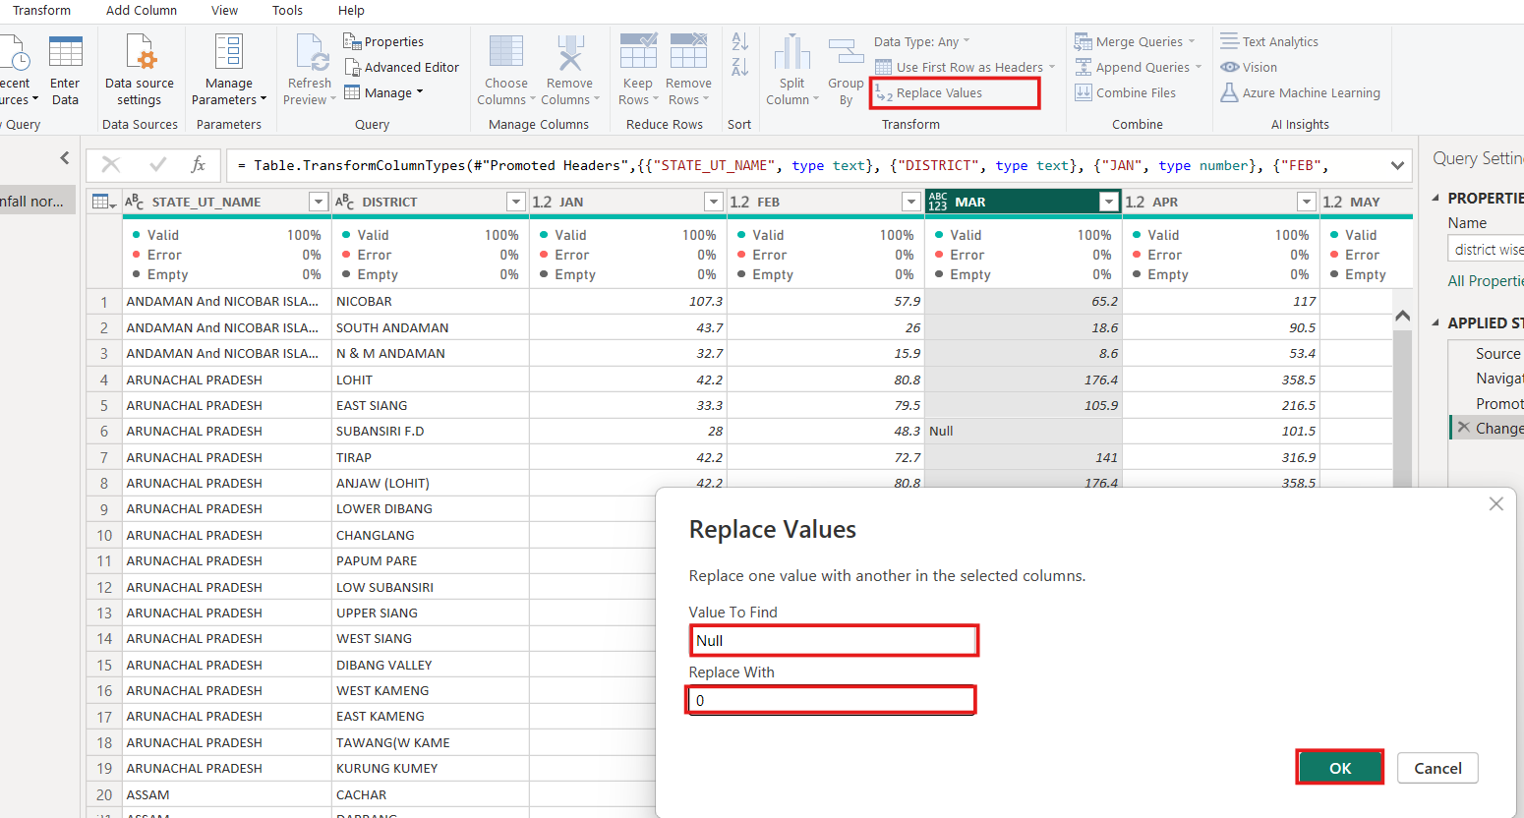

1. Handle Missing Data:
   * Inspect the data for any missing or null values. If any are found, decide how to handle them (e.g., replacing missing values with 0 or average).



1. Create New Columns for Seasonal Rainfall:
   * Add columns for seasonal rainfall totals:
     + Jan-Feb = JAN + FEB
     + Mar-May = MAR + APR + MAY
     + Jun-Sep = JUN + JUL + AUG + SEP
     + Oct-Dec = OCT + NOV + DEC

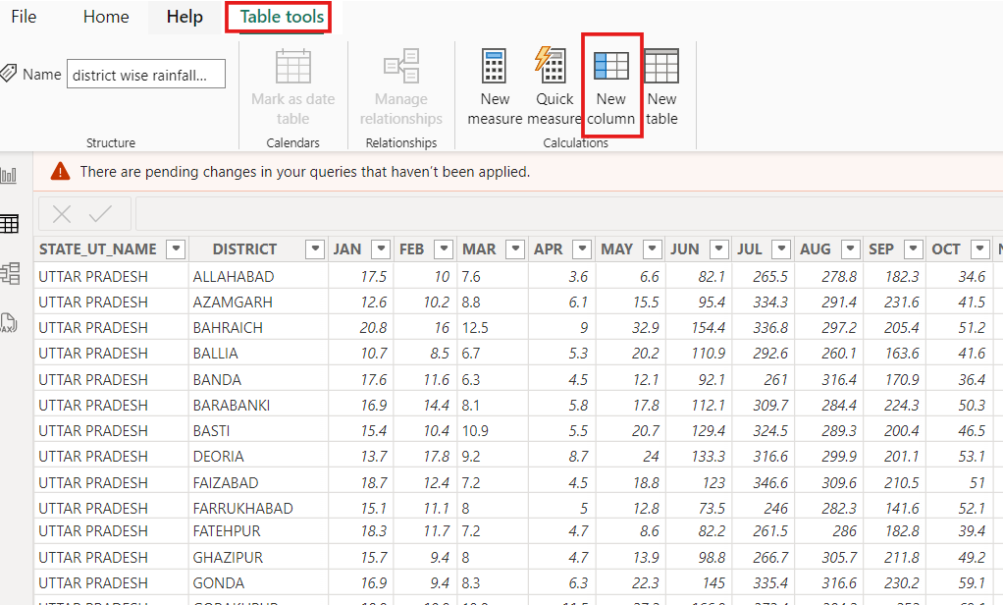

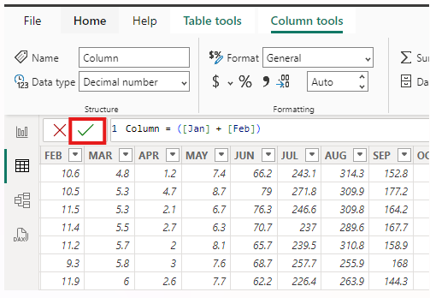

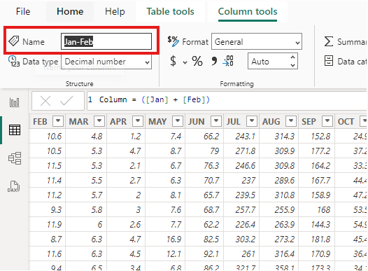

1. Save and Apply Changes:
   * Once data is cleaned and transformed, click Close & Apply to save the changes.

**Step 3: Data Modeling**

1. Check Relationships (if applicable):
   * If you have multiple tables (e.g., related demographic data), check the Model view to ensure that the relationships between tables are correctly set.

**Step 4: Visualization**

1. Create a Line Chart for Monthly Rainfall Trends:
   * Go to Report view.
   * Insert a Line Chart.
   * Add Month to the X-axis and Rainfall to the Y-axis.

Transform Data (Unpivot Columns)

To add Month as a separate column (to use as the X-axis), you'll need to unpivot the monthly rainfall data columns (JAN, FEB, MAR, ..., DEC).

Steps:

1. Open Power Query Editor:
   * Click Transform Data to open Power Query Editor.
2. Select the Month Columns:
   * In Power Query Editor, select all the columns containing the month names (JAN, FEB, MAR, ..., DEC).
3. Unpivot the Month Columns:
   * With the month columns selected, go to the Transform tab and click Unpivot Columns.

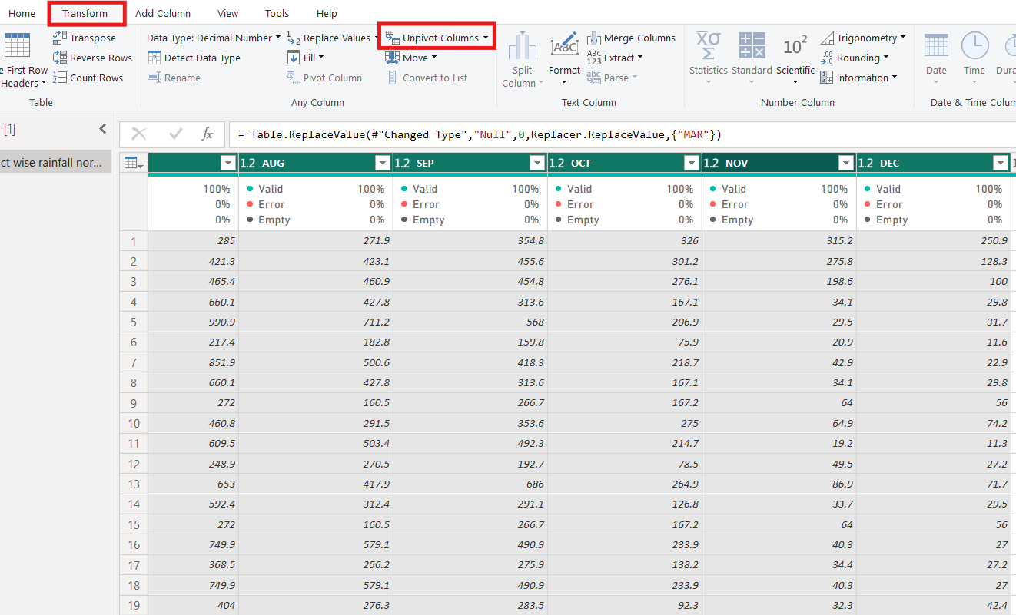

* + This will convert each month column into two columns: Attribute (which will represent the months) and Value (which will represent the rainfall values).

1. **Rename Columns:**
   * Rename the Attribute column to Month and the Value column to Rainfall.

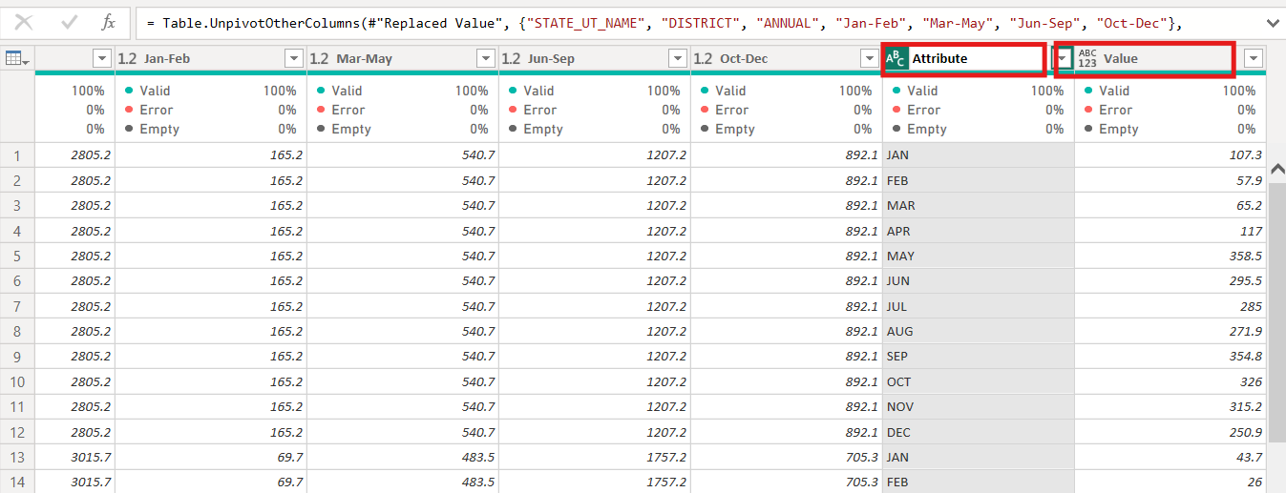

1. **Close and Apply:**
   * After unpivoting, click *Close & Apply* to apply the changes and return to Power BI.

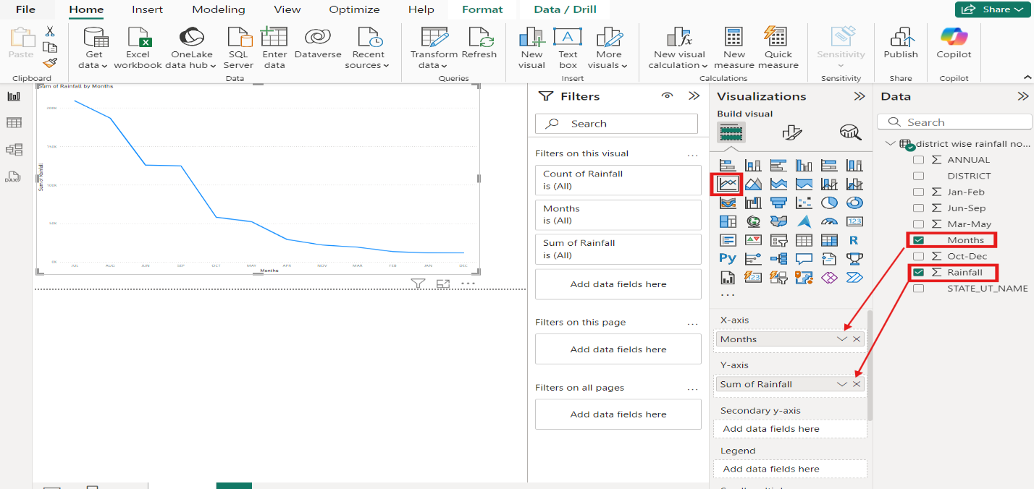

* + Use the slicer for STATE_UT_NAME or DISTRICT to allow for filtering by state or district.

1. **Create a Stacked Bar Chart for Seasonal Comparison:**
   * Insert a *Stacked Bar Chart*.
   * Add STATE_UT_NAME to the Axis, and seasonal columns (Jan-Feb, Mar-May, Jun-Sep, Oct-Dec) to the Values field.

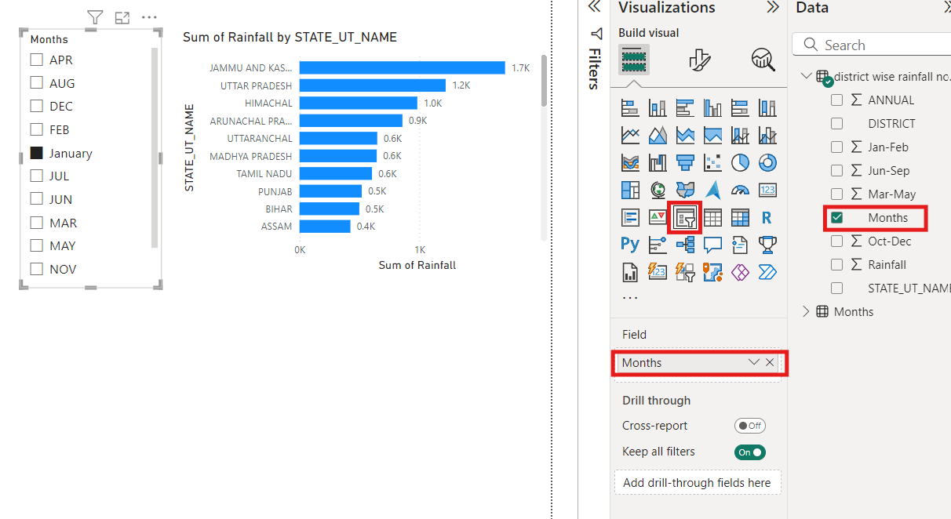

1. **Map Visualization (Optional):**
   * If geographic data is available, insert a *Map* visual to plot rainfall across different states or districts.
   * Add STATE_UT_NAME or DISTRICT to the Location field, and ANNUAL rainfall to the Value field.

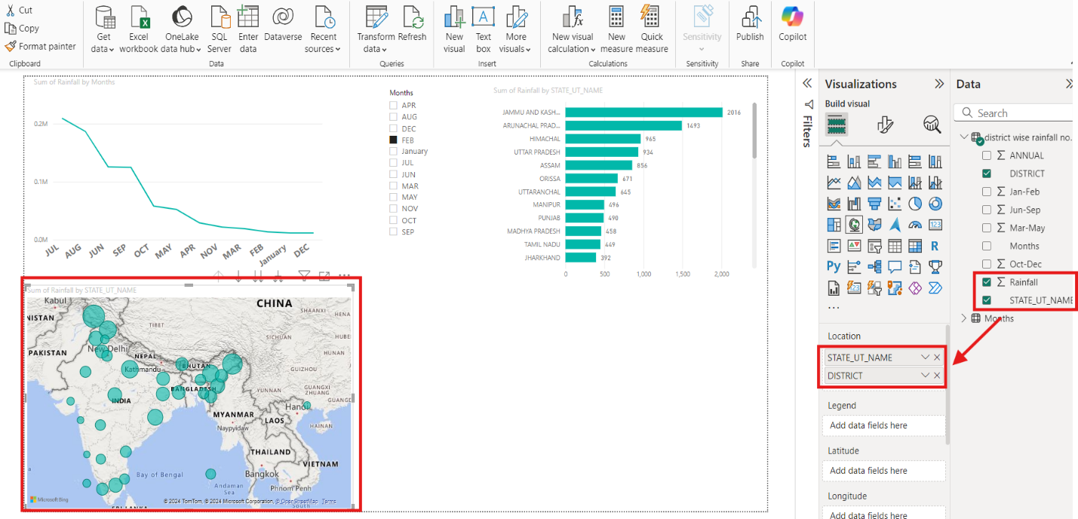

**Steps to Add State-wise Average Rainfall in Power BI**

Add a New Column for Annual Rainfall (if not already present)

Go to the Modeling tab and click New Column.

Use a DAX formula to calculate the annual rainfall:

AnnualRainfall = SUMX(VALUES('TableName'), 'TableName'[JAN] + 'TableName'[FEB] + ... + 'TableName'[DEC])

Replace 'TableName' with the Annual.

Build a Table or Map Visualization

For a table:

Drag STATE_UT_NAME to the Rows section and AvgRainfall to the Values section.

For a map:

Use the Map or Filled Map visualization.

Drag STATE_UT_NAME to the Location field and AvgRainfall to the Size or Values field.

Format the Visual

Apply Filters (Optional): Use slicers to filter data by year.

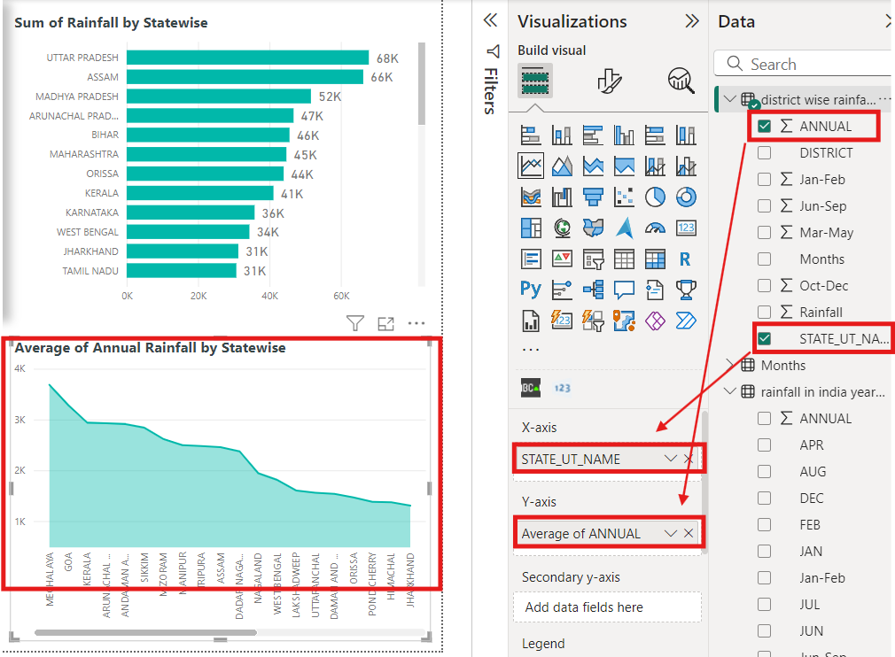

**Steps to Add Prediction Over Time in Power BI**

Load the Dataset containing yearwise data

Import the dataset containing time-series data into Power BI.

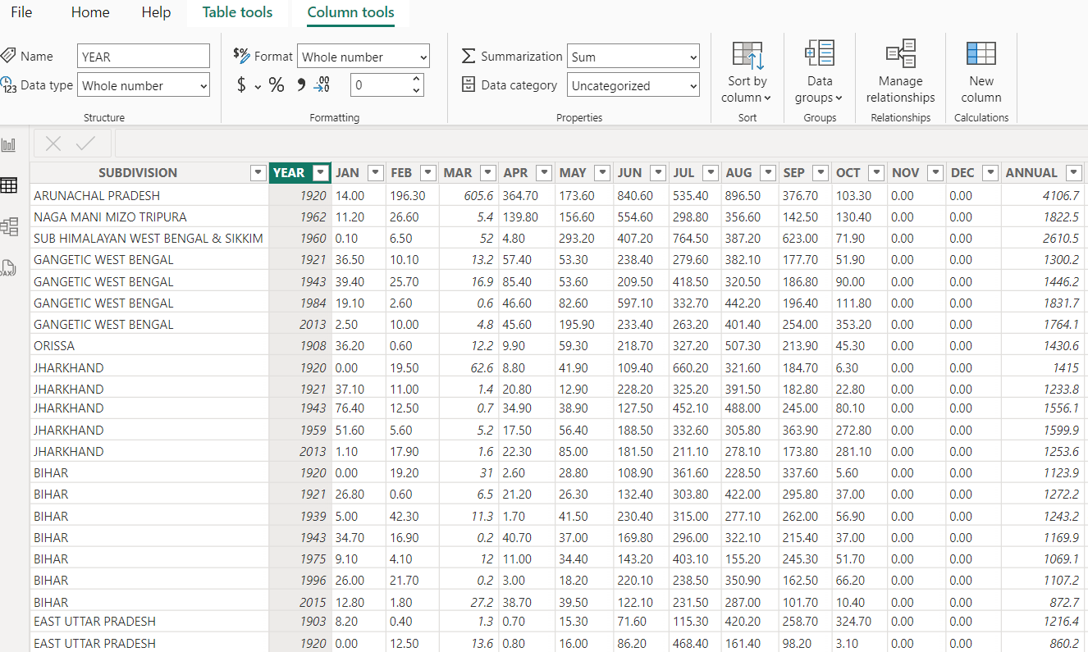

Create a Line Chart

Go to the Visualizations pane and select Line Chart.

Drag the time field (Year) to the X-axis.

Drag the measure (Annual Rainfall) to the Values section.

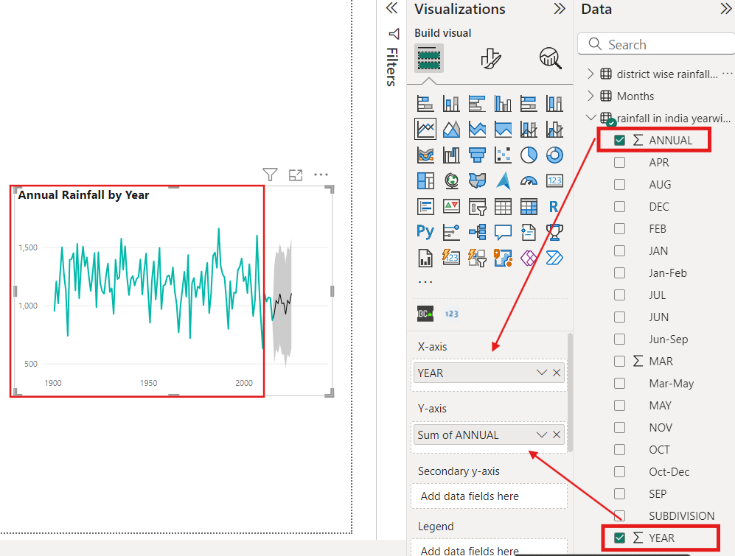

Enable Forecasting

Select the Line Chart.

In the Visualizations pane, click the Analytics tab (the magnifying glass icon).

Under Forecast, click Add to enable the forecasting feature.

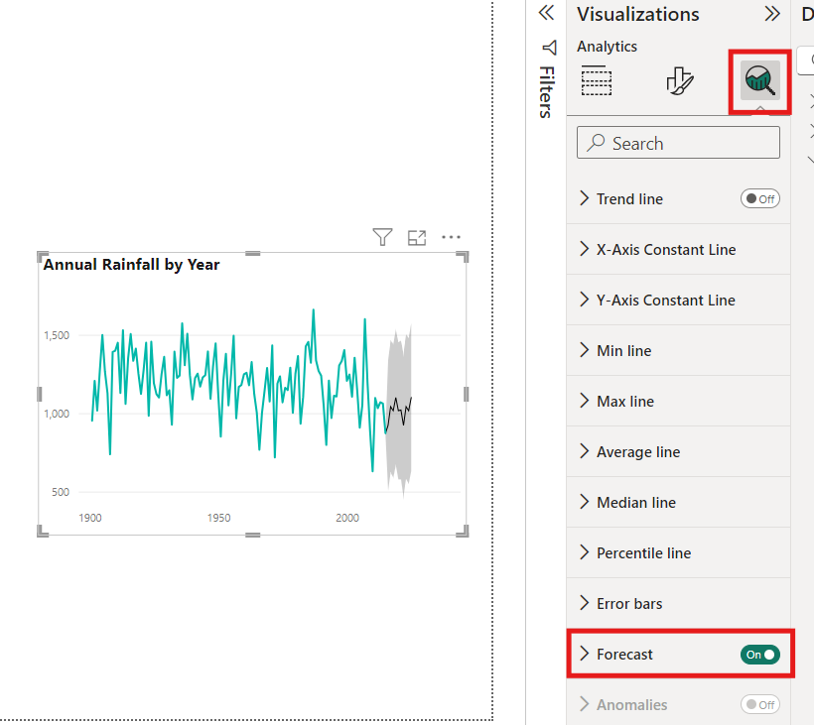

Configure Forecast Settings

Forecast Length: Set the number of data points into the future to predict (e.g., 12 months).

Confidence Interval: Specify a confidence level (e.g., 95%) to indicate the range of prediction accuracy.

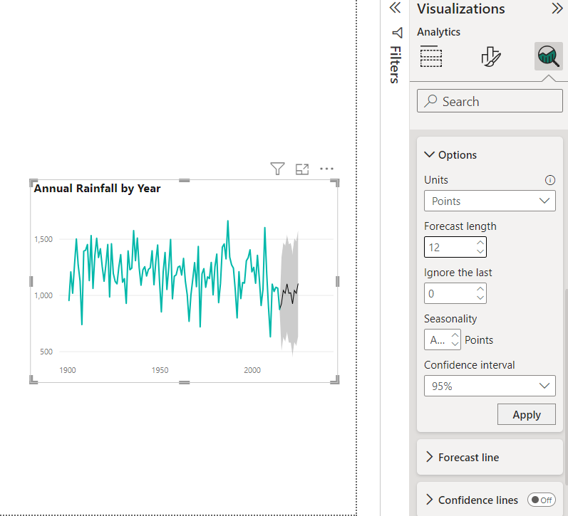

Customize the Forecast Appearance

Adjust colors, transparency, and styles to differentiate forecasted values from actual data.

Add labels for better interpretation of predicted data.

**Steps to Add a Scroller in Power BI**

 1. Open Power BI Report: Open an existing report or create a new one with the dataset you want to display.

 2. Import the Required Visual: To add a scrolling effect, you need to use a custom visual such as Marquee Scroll or similar:

**Open the Power BI Marketplace:**  
In the Visualizations pane, click on the three dots (ellipsis) at the bottom.  
Select Get more visuals.

1. Search for Scrolling Visuals:

* In the Marketplace search bar, type Marquee or Scroller.
* Select Marquee Visual or a similar visual (e.g., Scrolling Text).
* Click Add to import it into your report.

1. Add the Scroller to Your Report  
   Insert the Marquee Visual:  
   After importing, the Marquee visual will appear in your Visualizations pane.  
   Click on the visual to add it to your report canvas.
2. Set the Data Field: Drag the field you want to display in the scroller into the Values field of the Marquee visual.
3. Customize the Scrolling Effect
4. Test and Adjust:

* Preview the Scroller
* Adjust its size and position on the canvas to fit seamlessly into your report layout.

1. Save and Publish: Save Your Report

**Design the Dashboard Layout**

Arrange visuals on a single page with an intuitive flow.

Resize and align visuals for a clean and professional appearance.

**Dashboard:**

